Weekly Communication
November 12, 2023
Seabrook Middle School Mission Statement:
It is the mission of the Seabrook Middle School to generate a passion for learning, and to provide a safe atmosphere which is conducive to educating, nurturing, and empowering all students to become responsible, productive, tolerant members of society.

Good evening SMS Parents & Guardians,
I hope that you all enjoyed the long weekend and the sunshine.
Thanks to our students and Social Studies Department who facilitated an incredible Veteran’s Day Assembly Thursday morning. Thanks to the Veterans who attended and to all of you who provided pictures for our slideshow. Please go to the SMS website to view or click below.
https://docs.google.com/presentation/d/1LUJNctxGp97Rh7Cqkz-gFnuPh9ahI1njVAiUu8p9UH8/edit#slide=id.g297e269150c_0_60
I could not have been prouder of our student ambassadors, band, chorus and Brody Powers who played Taps at the conclusion. Students in the audience, which included some of our elementary grades, displayed support and respect to all in attendance.
Please continue to reach out to your child’s teacher when you have concerns. Thanks for your continued support for our school.
Be well,
Colleen
Veteran’s Day Program
Our Ambassadors at the meet and greet prior to the ceremony.
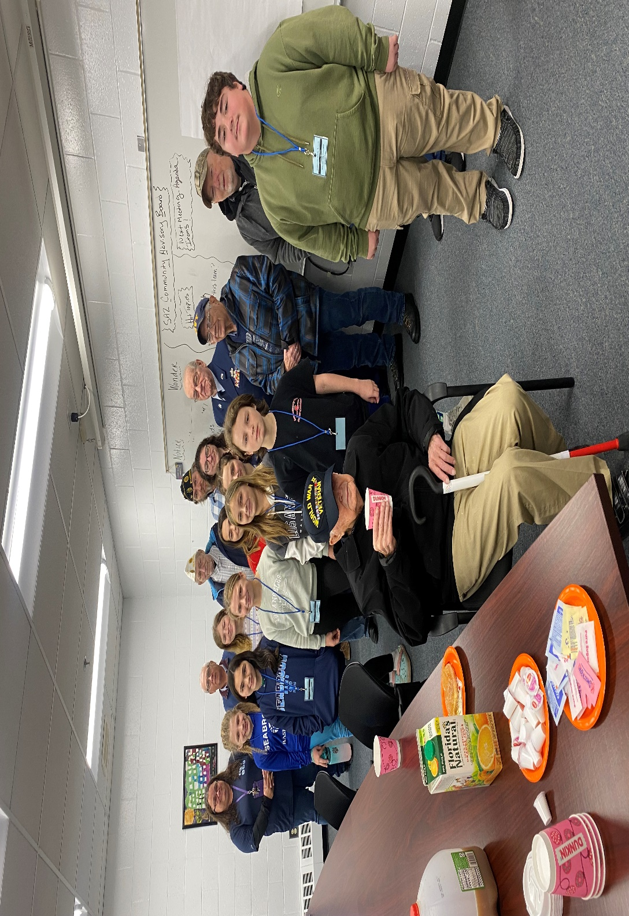

Invited Veterans who represented the Army, Navy, Air Force and a member of the Navy who served on the USS Rooks in World War II.
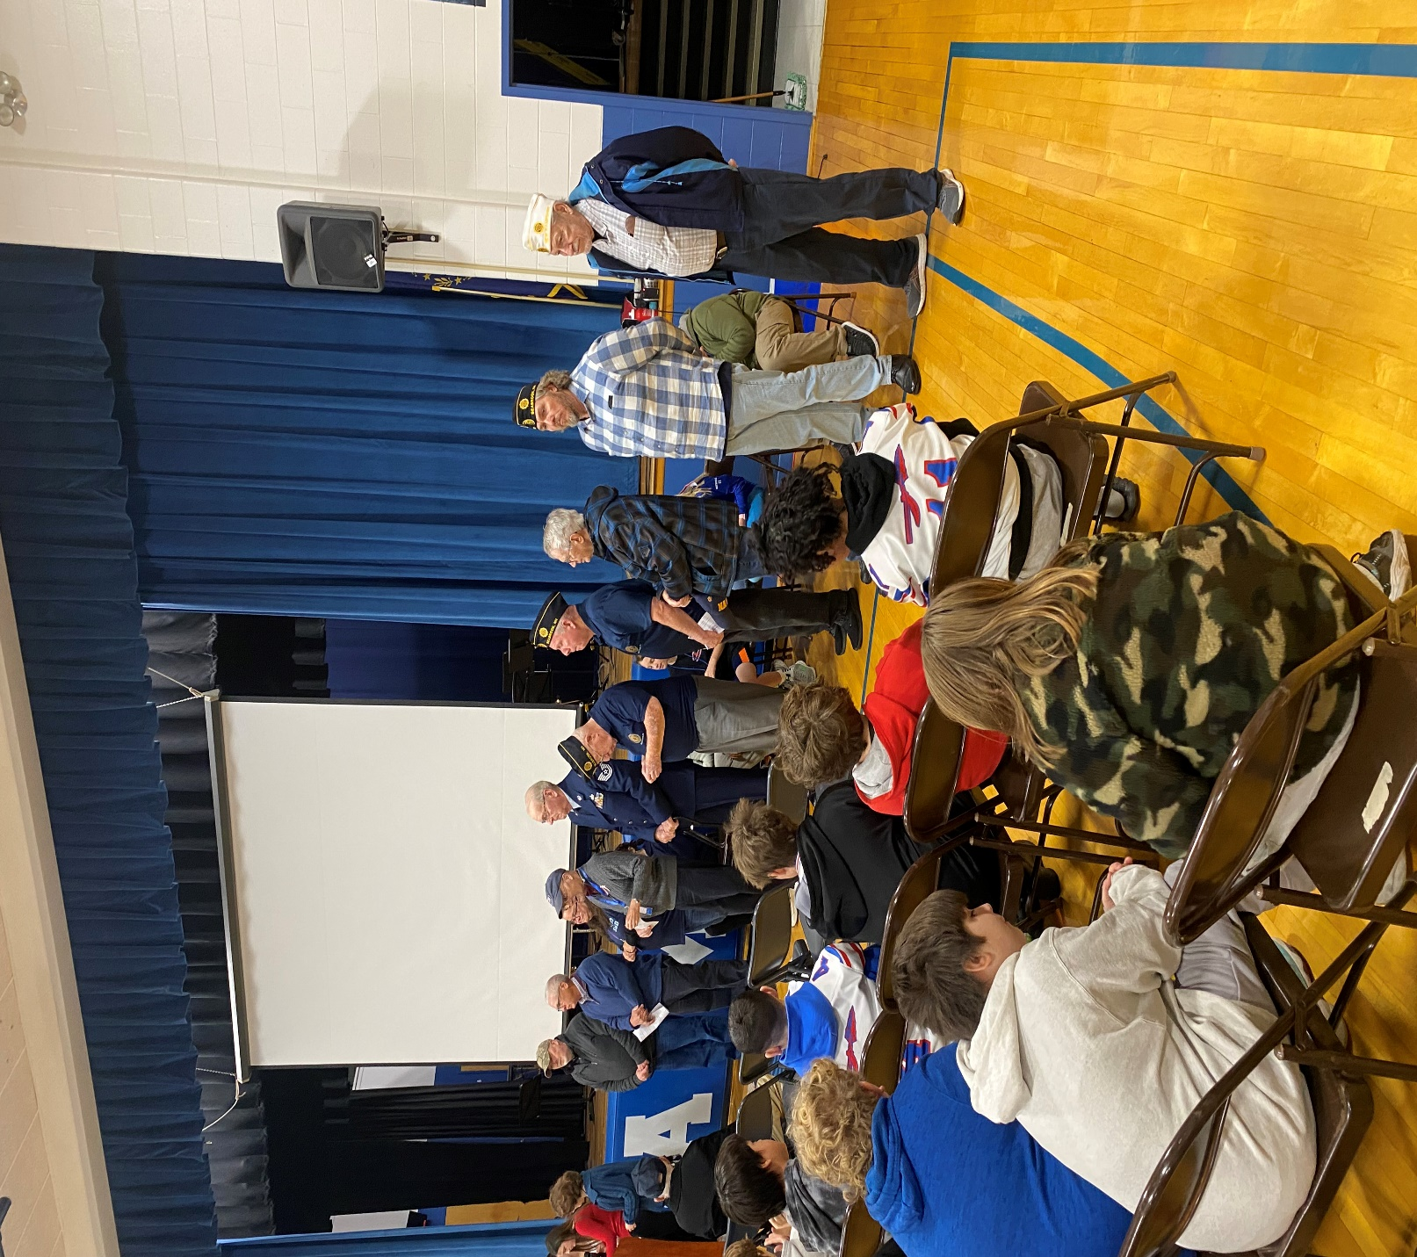

At the end of the program our students raising their stars to honor the Veterans.
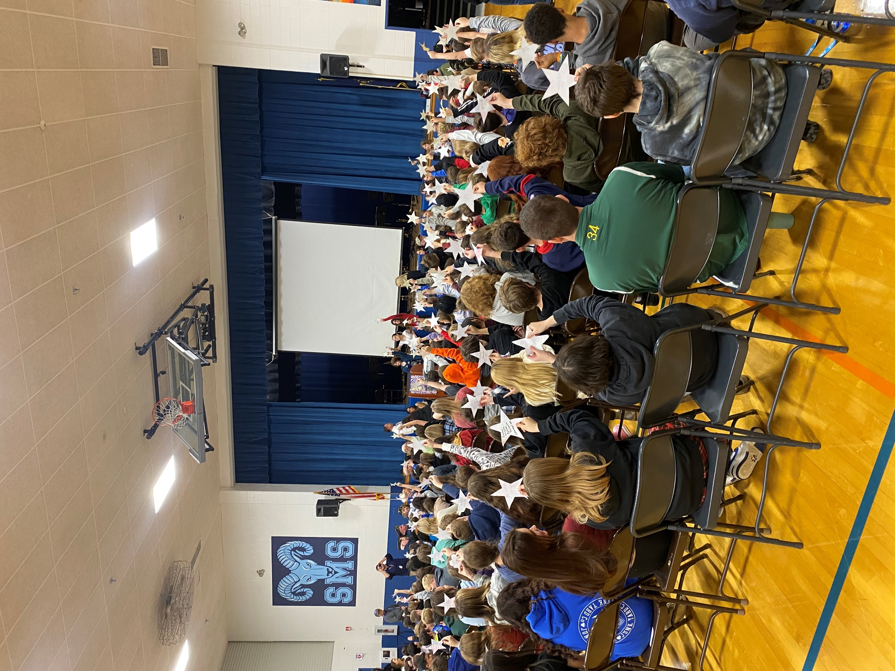
Core Instruction
Our Grade 5 ELA class had a professional development provider work with Ms. Riese and her students to support writing, students stated, “I had fun while also learning,”. Students used grade level text and new vocabulary as they wrote a short answer. This support is meant to help prepare students for the SAS in the Spring.
Staff will use the SAS practice modular and examine student work samples during vertical meetings.
Math tutoring will begin after Thanksgiving for targeted students. Two days a week additional supports will be available. Eligible students will receive an invitation/permission slip from their teacher

UA Schedule 11/13-11/17 ABCDA
Music Flex: Chorus, Band, Band, Clarinets, Chorus

Saxes after school Thursday Nov. 16th
UNH Field trip forms due Mon. Nov. 13th. Trip on Friday the 17th.

"C is for Cookie, it's good enough for me"- Cookie Monster
The cookies will be delivered and ready for pick-up outside of the cafe on Monday, Nov. 13th from 2-6pm. If for some reason you cannot pick up your order, please let Mr. Woolley know and he can hold onto it in the school freezer. mwoolley@sau21.org

Ski Club registration closes Nov. 14th."

Breakfast/Lunch

BREAKFAST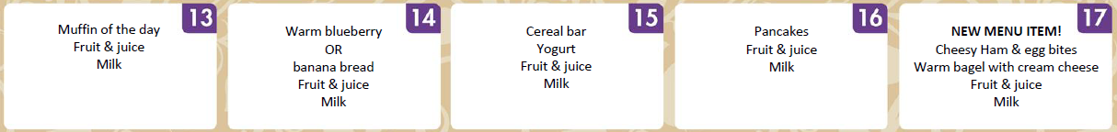

LUNCH
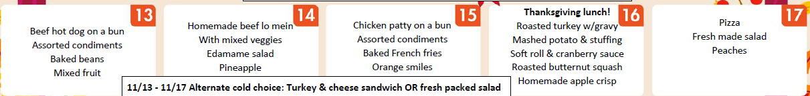
Please reach out directly to Lindsay Gaucher - Nutrition Director at lgaucher@sau21.org
Students
Our 8th Grade students are selling Holiday Wreaths for $25 to help offset the cost of the Washington, D.C. trip. Please let me know if you are interested in purchasing a wreath.

Meetings

School Board SMS Library- Tuesday, November 14, 2023 4:30-6:00 pm
Grade 5 Parent Check In- SMS Library-Wednesday, November 15, 2023 5:00-6:00 pm
Coming Attractions
Save the Date: Exhibition Night Thursday, November 30 5:30-7:00 pm
Revamped grade level schedules in Term 2. When they are approved by staff we will share them.
Student reps will be attend future School Board Meetings to report out student learnings and events.

